Veterinary Care Release Form/Waiver - Dog Daycare
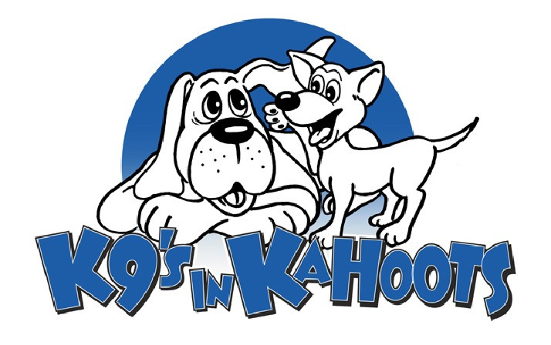

Dog(s) Name: Is your dog neutered/spayed?
Veterinary Clinic: Clinic Phone #:
What flea control product is your pet currently on?
Do you have pet insurance?
Does your pet have any health (i.e. allergies) or behaviour (i.e. biting) concerns that K9'S in KAHOOTS should be made aware of?

I understand that I am solely responsible for any harm caused by my dog(s) while my dog(s) is/are attending daycare at K9'S in KAHOOTS Inc.
I further understand that due to the way that dogs interact with one another, minor cuts and scratches can occur even though the dogs are carefully supervised at all times.
I also understand and agree that in admitting my dog(s), K9'S in KAHOOTS Inc. has relied upon my representation that my dog(s) is/are in good health and have not harmed or shown aggressive or threatening behaviour towards any person or any other dog.
In the event that my pet requires veterinary services while in the care of the professionals at K9'S in KAHOOTS Inc., I grant permission to Darlene Johnson, or an appointed associate to act on my behalf and agree to pay for any and all charges incurred, or any kenneling fees, which may result. If my usual veterinarian is unavailable, K9'S in KAHOOTS Inc. has my permission to use another veterinarian at their discretion.
I will not hold K9'S in KAHOOTS Inc., Darlene Johnson, or any associates of K9'S in KAHOOTS, responsible for any injury or illness my pet may suffer in their care.
I hereby release and agree to save and hold harmless, K9'S in KAHOOTS, it's directors, officers, shareholders, employees, assistants, members or agents from any and all liability, claims, suits, actions, loss, injury, or damage of any nature or kind, or for any liability, claims, suits, actions, loss, injury or damage which I or my dog(s) may sustain or which many be caused in any way by my dog(s). I specifically, without limitation, agree to fully indemnify K9'S in KAHOOTS Inc. for any and all such liability, claims, suits, actions, losses, injury or damage.
To the best of my knowledge, I have made K9'S in KAHOOTS Inc. aware of any and all concerns regarding my pet's health by noting them on this form. Further, I grant K9'S in KAHOOTS Inc. access to my pet's veterinary records.
I certify that I have read and understand the rules and regulations set forth herein and that I have read and understand this agreement. I agree to abide by the rules and regulations and accept all the terms, conditions and statements of this agreement and confirm the truthfulness of the contents of the Daycare Registration Form sheet completed by me.
My dog(s) is/are up to date on all necessary vaccinations including:
DHLPP (booster) Last vaccination date:
Rabies Last vaccination date:
Bordetella (kennel cough) Last vaccination date:

I , acknowledge that I have read and fully understand the above.

Signature: Date:
Witness: Date:

